A

Project

On

“Jumble Words Game”

By

Group No. 2

Vartika Kesarwani 18BTCSE011

Pariniti Kumari 18BTCSE016

Deepa Kumari 18BTCSE039

Jaya Maurya 18BTCSE037

Roshan Pandey 18BTCSE041

Under the Supervision of

Er. Vineesh Cutting



Department of Computer Science & Information Technology

Vaugh Institute of Agricultural Engineering & Technology

Sam Higginbottom University of Agriculture, Technology and Science

Prayagraj-211007, UP

(Formally Allahabad Agriculture Institute)

Introduction

The name of this game is ‘Jumbled Craze’. This game has a GUI Interface.

In this game, a word, each of which is “jumbled” by scrambling its letters is given on the screen. A solver reconstructs the word, by rewriting the letters in correct order on the white space.

A ‘Check, button is provided to see whether your answer is right or not and a button with name ‘Next’ is provided to the solver to switch from one jumbled word to other.

At first, when you run the program, you’ll see a message on the back end.



After this message, you’ll see a screen as follows…

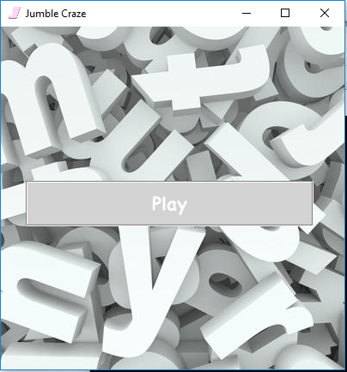

This screen has a title, a logo and a ‘Play’ Button on it. Click on the play button and you’ll now find a screen as follows…

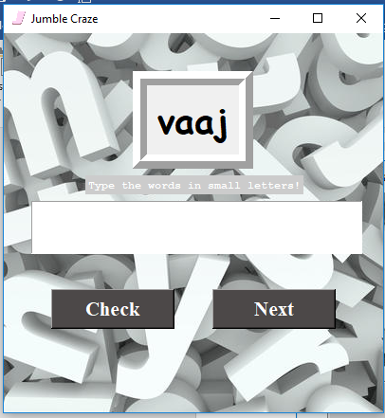

Here, a jumble word ‘vaaj’ is given and the solver’s task is to rearrange the letters of ‘v-a-a-j’ so that it forms a correct English word. Now, to check your rearranged word click on ‘Check’ and to change the word, click on ‘Next’.

Source Code

The game ‘Jumble Craze’ uses three modules (i.e. back_end, data, front_end), two images (i.e, a, bg) and a final executable program (i.e. run). To execute the program just have to click on the run file.

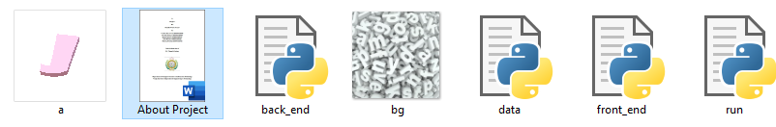

**run.py**

This file firstly imports some modules like front_end, data, back_end, tkinter & random and then inherited some features of tkinter module. After that, a ‘main’ method is created, which invokes all the commands required for the execution of a program. At the end, ‘main’ method is called.

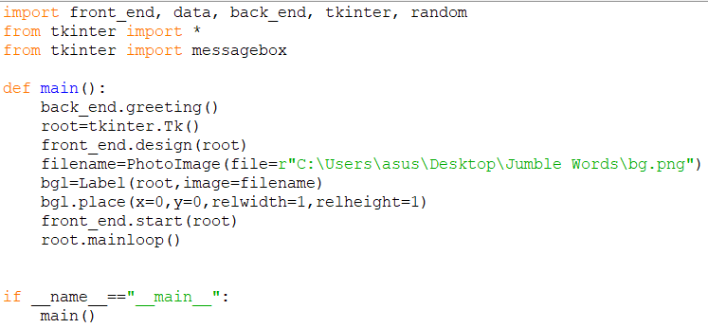

**back_end.py**

This module has a method named ‘greeting’, which is been used by the run.py file to greet the user at the beginning.



**data.py**

This module has the data of jumble words and the answer corresponding to it. This data is used by the front_end module.



**front_end.py**

The last, but not the least! Here comes boss of all the modules.

This file firstly imports tkinter, random & data modules and then inherited some features of tkinter module. After this, two variables are created, which is later been treated as global variable.

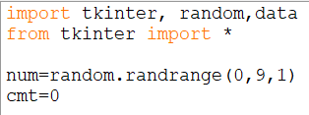

Here, ‘designs’ method defines the frame of the GUI interface.

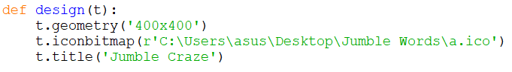

This ‘start’ method has an argument and used to create play button. The function of play button is to start the game.

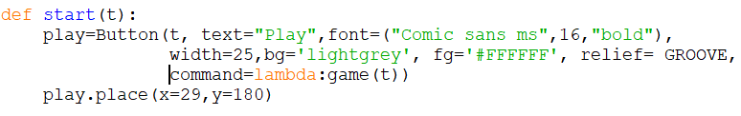

This method fully defines the second screen of our GUI interface.

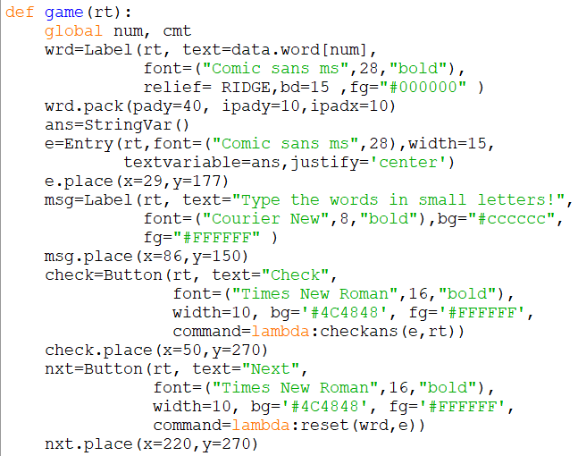

After writing the letters of a given word, you’ll click on the ‘Check’ button. What happens after clicking on check button is defined by this ‘checkans’ method.

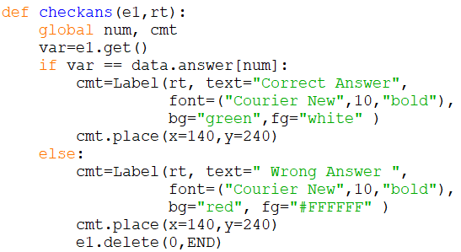

This ‘reset’ method defines the function of ‘Next’ button.

